Exp no: 2 Implement programs for visualizing time series data

Date: 31/1/25
Objectives:
The primary objective of this analysis is to visualize and analyze the time series data of airline passengers from 1949 to 1960. By plotting the data and performing seasonal decomposition, we aim to identify trends, seasonal patterns, and residuals in the dataset. This will help in understanding the underlying structure of the data and provide insights for further time series forecasting or modeling.
Background/Scope:
The Air Passengers dataset is a classic time series dataset that records the number of international airline passengers each month from 1949 to 1960. It is widely used for time series analysis and forecasting due to its clear trend and seasonal patterns. This analysis focuses on visualizing the data, identifying trends, and decomposing the time series into its components (trend, seasonality, and residuals) to gain a deeper understanding of the dataset.

Steps for Time Series Sales Data Preprocessing:
Step 1: Load the Dataset
Load the dataset from a local CSV file and display the first few rows to understand its structure.

import pandas as pd
# Load the dataset
file_path = "contents/AirPassengers.csv" # Replace with the actual path to your CSV file
data = pd.read_csv(file_path)
# Display the first few rows
print(data.head())

Step 2: Preprocess the Data
Convert the Month column to a datetime object and set it as the index for time series analysis.

# Convert 'Month' to datetime and set as index
data['Month'] = pd.to_datetime(data['Month'])
data.set_index('Month', inplace=True)
# Display the updated dataset
print(data.head())

Step 3: Visualize the Time Series Data
Plot the time series data to visualize the trend of airline passengers over time.

import matplotlib.pyplot as plt
# Plot the time series data
plt.figure(figsize=(12, 6))
plt.plot(data.index, data['Passengers'], color='blue', marker='o', linestyle='-')
plt.title('Air Passengers Over Time (1949-1960)')
plt.xlabel('Month')
plt.ylabel('Number of Passengers')
plt.grid(True)
plt.show()

Step 4: Perform Seasonal Decomposition
Decompose the time series into its trend, seasonal, and residual components using statsmodels.

from statsmodels.tsa.seasonal import seasonal_decompose
# Perform seasonal decomposition
decomposition = seasonal_decompose(data['Passengers'], model='multiplicative')
# Plot the decomposition
plt.figure(figsize=(12, 8))
plt.subplot(4, 1, 1)
plt.plot(decomposition.trend, color='blue')
plt.title('Trend Component')
plt.subplot(4, 1, 2)
plt.plot(decomposition.seasonal, color='green')
plt.title('Seasonal Component')
plt.subplot(4, 1, 3)
plt.plot(decomposition.resid, color='red')
plt.title('Residual Component')
plt.subplot(4, 1, 4)
plt.plot(data['Passengers'], color='purple')
plt.title('Original Time Series')
plt.tight_layout()
plt.show()

Step 5: Interpret the Results
Analyze the plots to understand the trend, seasonality, and residuals in the dataset. The trend component shows the long-term increase in passengers, the seasonal component reveals periodic fluctuations, and the residuals represent the noise or irregularity in the data.
output :
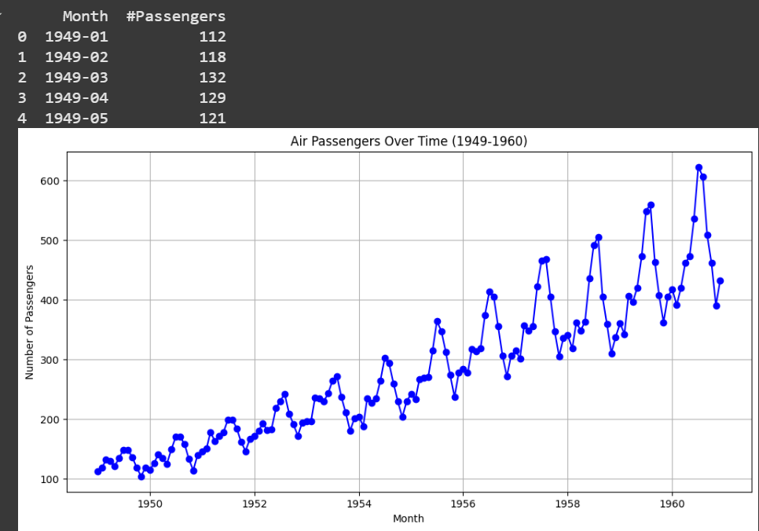
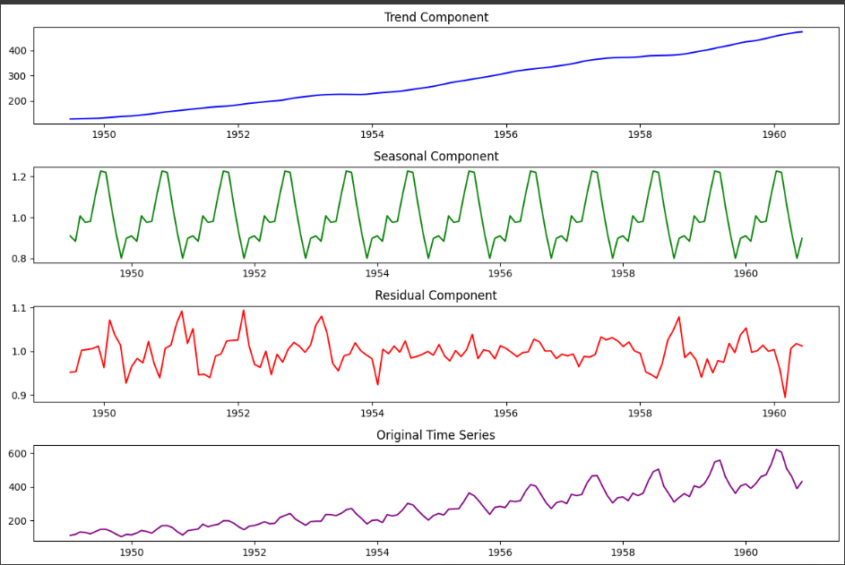
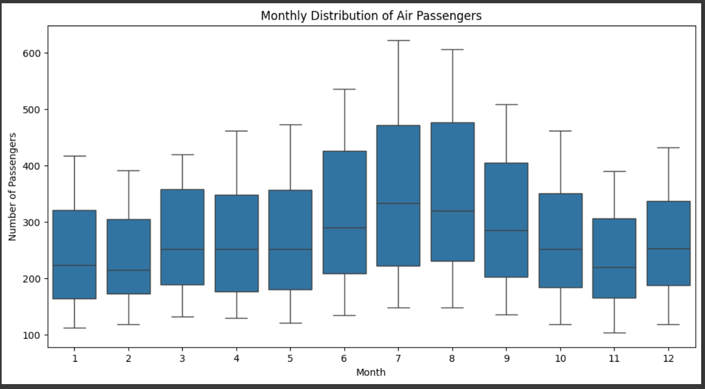
Result:
Thus the time series dataset is visualized successfully.

